CYCLE 1

EXPERIMENT 1

1. Consider the database for an organization**.** Write the queries for the following.

Create the database

Select the current database (iii)Create the following tables.

**employee** (emp_no,emp_name,DOB, address, doj, mobile_no, dept_no, salary).

**department** (dept_no, dept_name, location).

a) Include necessary constraints.

b) List all the tables in the current database

c) Display the structure of the employee table

d) Add a new column Designation to the employee table

e) Drop the column location from Dept table

f) Drop the tables

g) Delete the database

**CODE:**

**a.**

create database course;

use course;

create table employee(emp_no int(10),emp_name Varchar(20), DOB varchar(10),address Varchar(30),DOJ varchar(10),mobile_no int(13),dept_no int(10), salary int(10),PRIMARY KEY(emp_no),FOREIGN KEY(dept_no) references department(dept_no));

select *from employee;

create table department(dept_no int(10), dept_name varchar(20),location varchar(20),PRIMARY KEY(dept_no));

select *from department;

alter table employee modify emp_no int not null;

alter table employee modify dept_no int (10) not null;

**b.**

show tables;

**c.**

describe employee;

**d.**

alter table employee add Designation varchar(20);

**e.**

ALTER TABLE department drop location;

**f.**

drop table employee;

drop table department;

**g.**

drop database course;

**OUTPUT :**

**b.**

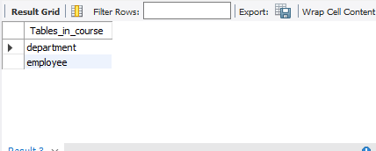

**C.**

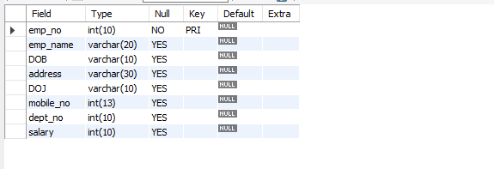

**d.**

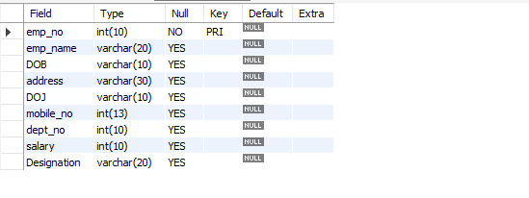

**e.**

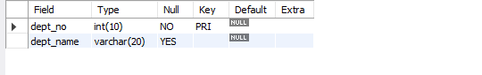

Consider the database for an organisation. Write the queries for the following

1. Add 5 rows in the employee and dept tables
2. Display all the records from the above tables
3. Display the empno and name of all the employees from department no2
4. Display empno,name,designation,dept no and salary in the descending order of salary
5. Display the empno and name of all employees whose salary is between 2000 and 5000
6. Display all designations without duplicate values.
7. Display the dept name and total salary of employees of each department.
8. Change the salary of employees to 25000 whose designation is ‘Typist’
9. Change the mobile no of employee named ‘john’
10. Delete all employees whose salaries are equal to Rs.7000

Select the department that has total salary paid for its employees more than 25000

**CODE:**

1.

#insertion of data into table 1

insert into employee values('122','JOHN','16/02/1996','ATTINGAL','19/10/2019',1234567,1,7000,'AI ENGINNER');

insert into employee values('123','AMAL','18/07/1998','TVM','16/02/2019',3224367,2,10000,'DATA SCIENTIST');

insert into employee values('124','JOHN','13/08/1999','KOLLAM','26/05/2018',6324893,3,6300,'CLOUD ARCHITECT');

insert into employee values('125','LUCKY','26/07/1994','ALAPPUZHA','27/08/2022',097538,4,4900,'Typist');

insert into employee values('126','MICHAEL','23/09/1999','KOCHI','26/12/2018',232347,5,19000,'CEO');

insert into employee values('129','AKHIL','16/02/1996','ATTINGAL','19/10/2019',12349567,1,19500,'AI ENGINNER');

#insertion of data into table 2

INSERT INTO department values('1','AI');

INSERT INTO department values('2','DS');

INSERT INTO department values('3','CLOUD');

INSERT INTO department values('4','DEV');

INSERT INTO department values('5','ADMIN');

2.

#display commands question 2

select *from department;

select * from employee;

3.

select emp_no,emp_name from employee where dept_no=2;

4.

select emp_no,emp_name,designation,dept_no,salary from employee order by salary desc;

5.

select emp_no,emp_name from employee where salary between 2000 and 5000;

6.

select distinct designation from employee;

7.

select department.dept_name ,sum(employee.salary) as SUM_SALARY from department join employee on (department.dept_no=employee.dept_no) group by dept_name;

8.

update employee set salary=25000 where designation='Typist';

9.

update employee set mobile_no=975934 where emp_name="JOHN";

10.

delete from employee where salary=7000;

11.

select department.dept_name,sum(employee.salary) as total_salary from department join employee on(department.dept_no=employee.dept_no) group by dept_name having sum(employee.salary)>20000;